Astoria Park Elementary School
DR. CASSANDRA J. POOLE
Principal

KATRINA BRADWELL
Assistant Principal
2465 Atlas Road

Tallahassee, Florida 32303
(850) 488-4673 Fax: (850) 922-4174

2024 - 2025 School Supply Lists
Third Grade
3 - Dozen #2 Pencils
1 - Pencil Box
2 - boxes of Kleenex Tissues
1 - Pack of Erasers
1 - 80 ct. containers of Lysol/Clorox Wipes
2 – packs of 3-hole Pack of Notebook Paper

Regular Size Backpack with NO Wheels
Suggested Homework Resources for 3rd Grade
Basic material for homework would include: pencils/erasers for home, a dictionary, and ruler with inches and centimeters.

Fourth Grade
24-48 - #2 Ticonderoga pencils
1 - Box 24 ct. Crayola Crayons
2-4 of Block Erasers (not pencil top)
4 - Wide Rule Composition Notebooks
1 - 1” Clear View Binder
1 pack of 5 Tab Dividers
1 - Pack of Sheet Protectors
1 pack of 5 color highlighters
1 - Pack of 16 ct. Crayola Colored Pencils - Crayola
2 - 80 ct. Clorox Wipes
4 - Box of Kleenex Tissues
1 - 2 liter Purell Hand Sanitizer
Large Size Backpack with NO Wheels

Fifth Grade
2 - Boxes - #2 Pencils
2 - Package Colored Pencils
1 - 2” 3 ring binders
2 - Packages of Subject Dividers
6 - Composition notebooks
Glue Sticks
Student Scissors
Individual Tissue
Individual Hand Sanitizer
Pencil Pouch
Backpacks CAN have rollers …only fifth grade

PANTHER PRIDE

Pre-K
1- Mat for Napping
1- Small Blanket/Towel for Napping
2-Packs of Baby Wipes (for face)
Regular Size Backpack with NO Wheels
Change of Clothes – all items labeled with child’s name and placed in a labeled bag. (1 set for Fall; 1 set for Spring)
Healthy snack each day – no glass containers or carbonated beverages.

Kindergarten
Please put name on Backpack and change of clothes only.
12 - Elmer’s Glue Sticks
1 - Pack of Washable Markers
1 - pack of thin black Expo Markers
2 - Ziploc Gallon Bags
1 - pair of Student Headphones
2 - Kleenex Tissues
1 - Baby Wipes
1 - Disinfecting Wipes
Large Size Backpack with NO Wheels
Change of Clothes – all items labeled with child’s name and placed in a labeled bag.
Healthy snack each day – no glass containers or carbonated beverages.

First Grade
1 - 1˝ White View Binder
1 - Box of Expo Markers
2 - Boxes of 24 pack Crayola Crayons
1 - Pair of Student Scissors
3 - Dozen of Pencils
1 - Pencil Box
1 - pack of Erasers
2 - Box of Kleenex Tissues
1 - can of Lysol Spray
1 - large 16 oz. bottle of Hand Sanitizer
1 - 80 ct. containers of Lysol/Clorox Wipes
1 - pair of Student Headphones
1 - box of quart Ziploc bags
1 - box of gallon Ziploc bags
Regular Size Backpack with NO Wheels

Second Grade
Please put name on Scissors and backpack only
1 - Ruler (inches and centimeters)
1 - Pair of children’s 5” pointed Fiskar scissors
3 - Small Glue Sticks
4 - Boxes 24 Count Crayola Crayons
2 - Dozen – Pencils
3 - Packages of Big Erasers
1 - Canvas Pencil Pouch
1 - Student Headphone
2 - large 16 oz. bottle of Hand Sanitizer
3 - 80 ct. containers of Lysol/Clorox Wipes
NO Pencil Boxes
Regular Size Backpack with NO Wheels

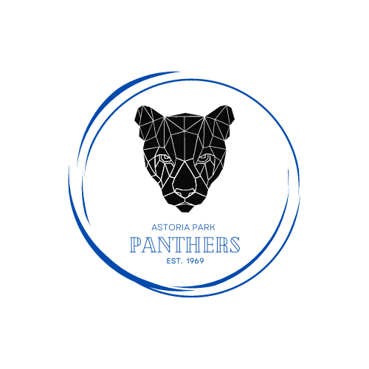


“The Leon County School District does not discriminate against any person on the basis of sex (including transgender status, gender nonconforming, and gender identity), marital status, sexual orientation, race, religion, ethnicity, national origin, age, color, pregnancy, disability, or genetic information.”

